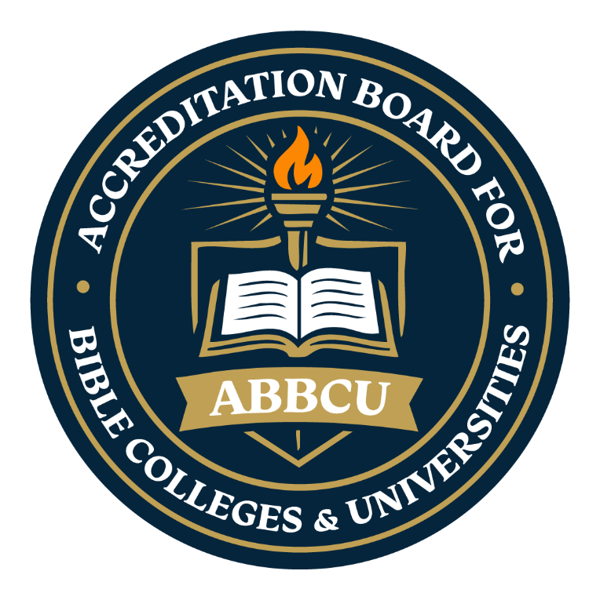
The Accreditation Board for Bible
Colleges & Universities

Educational Integrity Acknowledgement
“Maintaining Biblical Integrity in Higher Education”

Introduction

Educational Integrity Principles and Expectations
The Accreditation Board for Bible Colleges & Universities (ABBCU) is committed to upholding the highest standards of educational integrity among all institutions operating under its accreditation. These standards serve as the foundation for ensuring that Christian education remains both biblically faithful and academically credible. Institutions accredited through ABBCU are expected to affirm, maintain, and actively demonstrate the following core principles and values:

1. Instructional Excellence
Institutions accredited by the Accreditation Board for Bible Colleges & Universities (ABBCU) are called to pursue academic excellence that is both intellectually rigorous and spiritually enriching. Accredited institutions are expected to demonstrate the following:

• Employ qualified faculty members who are capable of integrating biblical truth with sound academic instruction and effective teaching practices.
• Provide ongoing faculty development, training, and academic oversight to ensure continued instructional quality and professional growth.
• Maintain high standards in curriculum development, course delivery, instructional methodology, and student assessment to promote meaningful educational outcomes and theological integrity.
2 Qualified and Godly Faculty
Employ faculty members who demonstrate appropriate academic qualifications, spiritual maturity, Christian character, doctrinal soundness, and a commitment to excellence in biblical instruction and student development.
3. Biblically Sound Curriculum
Ensure that all instructional content, academic materials, and curricula are biblically grounded, theologically sound, and aligned with the doctrinal principles affirmed by the Accreditation Board for Bible Colleges & Universities.
4: Faculty Integrity and Professional Conduct
The faculty of any institution serves a central role in shaping the academic, spiritual, and ethical environment of institutions accredited by the Accreditation Board for Bible Colleges & Universities. As both educators and Christian role models, faculty members are expected to exemplify integrity, professionalism, and biblical character in their teaching, scholarship, leadership, and interactions with students, colleagues, and the broader community.

Faculty members are responsible for maintaining honesty, fairness, and accountability in all instructional and academic practices. This includes presenting accurate information, evaluating students impartially, respecting intellectual property, and upholding the doctrinal and ethical standards established by the institution and ABBCU.

To preserve the integrity of Christian higher education, faculty members are expected to:

To ensure instructional integrity, institutions must ensure that there are policies in place to ensure::
Faculty are Spiritually and Academically Qualified
Teaching that Reflects Doctrinal Faithfulness
Faculty Adhere to Ethical Conduct
Course Content is Accurate and Relevant
Ongoing Professional Development is Encouraged
Educational integrity is more than a set of policies and procedures—it is the foundation upon which credible, effective, and Christ-centered education is built. Institutions that commit themselves to honesty, accountability, fairness, and academic excellence demonstrate their dedication to serving students, faculty, and the broader community with integrity and purpose. By fostering an environment where ethical conduct is expected and upheld, institutions strengthen the value of their educational programs and maintain the trust of those they serve.

As educational environments continue to evolve, commitment to integrity must remain unwavering. Through responsible leadership, transparent practices, respect for intellectual property, and a culture of academic honesty, institutions can ensure that learning remains both meaningful and transformative. Educational integrity not only safeguards the reputation of an institution but also helps develop graduates who are prepared to lead with character, wisdom, and ethical responsibility in their ministries, professions, and communities.

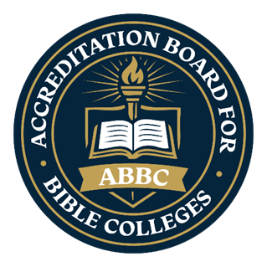

The Accreditation Board for Bible Colleges & Universities

(ABBCU)

Educational Integrity Affirmation
This form must be signed to acknowledge that the institution agrees to adhere to ABBCU's Education Integrity Standards.

☐ We affirm that our institution entirely agrees with and adheres to the Educational Integrity Standards of the Accreditation Board for Bible Colleges & Universities (ABBCU). We are committed to upholding the biblical, academic, and ethical principles outlined in this policy, reflecting our institution’s mission and stewardship of Christian education.

Please complete and sign below as part of your institution’s accreditation.
Institution Name: ____________________________________________
Authorized Representative (Print Name): __________________________
Title/Position: _______________________________________________
Signature: __________________________________ Date: ___________
Additional Representative (if applicable): _________________________
Signature: __________________________________ Date: ___________

Appendix A

