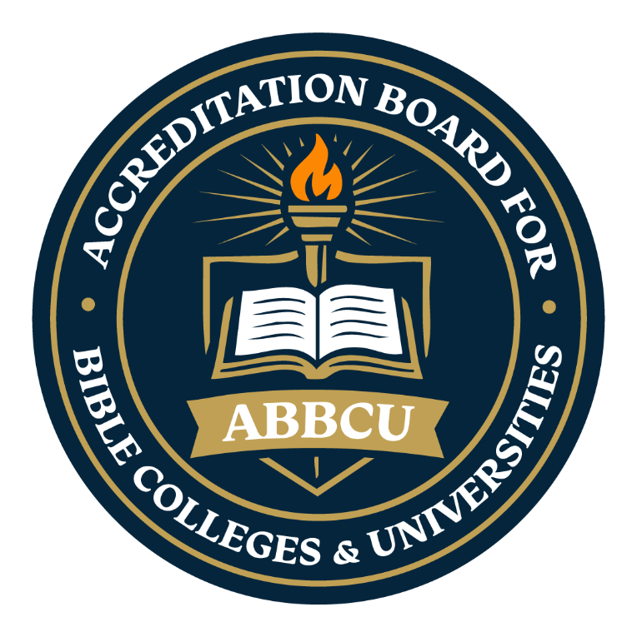
Application Packet Request Form
Thank you for your interest in pursuing accreditation through the Accreditation Board for Bible Colleges & Universities (ABBCU).
To obtain your official Accreditation Application Packet and begin the accreditation process, please complete the request form below and submit it to info@abbc.institute, along with the required non-refundable application fee of $75.00.
Upon receipt of your request, our processing team will review your submission and send an acknowledgment email confirming receipt. You will then be issued a private institutional access code. Your application packet will contain detailed instructions outlining the next steps in the accreditation process.
We look forward to assisting your institution as you pursue accreditation and demonstrate your commitment to academic excellence, biblical integrity, and institutional accountability.
Institution Name: _______________________________________________________________
Institution Address: _____________________________________________________________
(City) (State) (Zip Code)

Website: _________________________________________________________

Primary Contact Name: _____________________________________
Title/Role: __________________________________
Email Address: _____________________________________________
Phone Number: _______________________________
Institution Type:□ Bible College □ Seminary □ University □ Other__________________
Year Founded: _________________ Estimated Enrollment: ________________________
Programs Offered: □ Certificates □ Diplomas □ Degrees
Doctrinal Affiliation / Denomination (if any):__________________________________
Important: Please ensure that the email address provided on your Application Packet Request Form is active, accurate, and regularly monitored. All accreditation correspondence, including acknowledgment of receipt, institutional access code, requests for additional information, and official accreditation communications, will be sent to the email address provided. The Accreditation Board for Bible Colleges & Universities (ABBCU) is not responsible for delays resulting from incorrect, inactive, or inaccessible email addresses.
“Maintaining Biblical Integrity in Higher Education”

