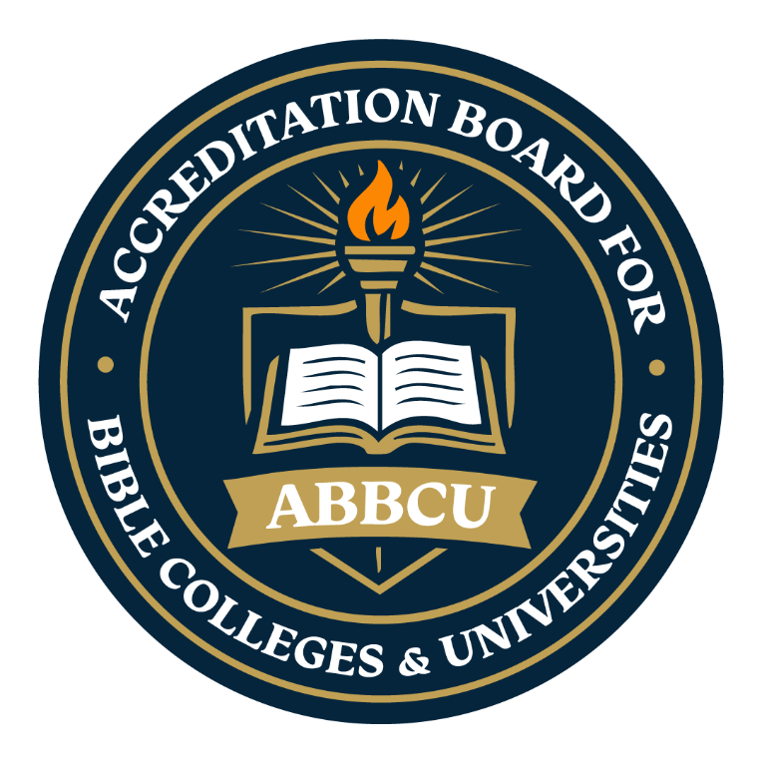
  - The Accreditation Board for Bible Colleges & Universities
  - “Maintaining Biblical Integrity in Higher Education”
  - Statement of Faith

Introduction to the Statement of Faith
The Statement of Faith of the Accreditation Board for Bible Colleges & Universities (ABBCU) establishes the foundational biblical convictions that guide the accreditation standards, educational philosophy, and spiritual expectations of affiliated institutions. It serves as a theological framework designed to promote doctrinal integrity, unity in essential Christian beliefs, and faithfulness to the authority of Scripture throughout Christian higher education.
ABBCU recognizes that accredited institutions may represent diverse Christian traditions; however, all participating institutions are expected to affirm and uphold the core doctrines reflected within this Statement of Faith as a condition of alignment with ABBCU’s mission and standards.
By affirming this Statement of Faith, institutions demonstrate their commitment to preserving sound biblical teaching, integrating Christian worldview principles into academic and ministerial preparation, and fostering environments that encourage spiritual growth, academic excellence, and faithful Christian leadership.

1. The Authority of Scripture
We believe the Bible, composed of the Old and New Testaments, is the inspired, infallible, and authoritative Word of God. It is the supreme standard for faith, life, and the pursuit of truth. (2 Timothy 3:16-17; 2 Peter 1:20-21; Psalm 119:89)

2. The Triune God
We believe in one God, eternally existent in three persons: God the Father, God the Son, and God the Holy Spirit—coequal in power and glory. (Deuteronomy 6:4; Matthew 28:19; 2 Corinthians 13:14)

3. The Lord Jesus Christ
We believe in the deity of our Lord Jesus Christ, His virgin birth, sinless life, miracles, atoning death on the cross, bodily resurrection, ascension into heaven, and His personal and glorious return. (John 1:1-14; Colossians 1:15-20; Acts 1:11; Revelation 19:11-16)

4. The Holy Spirit
We believe the Holy Spirit convicts of sin, regenerates the repentant heart, indwells the believer, empowers for service, and imparts spiritual gifts for the edification of the Church. (John 14:26; Romans 8:11; 1 Corinthians 12:4-11)

5. The Sinfulness of Man and the Need for Salvation
We believe all humanity is sinful by nature and choice, separated from God, and in need of salvation through faith in Jesus Christ. (Romans 3:23; Romans 5:12; Ephesians 2:8-9)

6. Salvation Through Christ Alone
We believe salvation is a gift of God’s grace, received by faith in Christ alone, and evidenced by a transformed life of obedience and holiness. (John 3:16; Acts 4:12; Titus 3:5-7)

7. Sanctification and Holy Living
We believe in the sanctifying power of the Holy Spirit, enabling believers to live in righteousness, resist sin, and reflect the character of Christ. (Romans 6:19; Galatians 5:22-25; 1 Peter 1:15-16)
8. The Church
We believe the Church is the Body of Christ, composed of all born-again believers, called to worship God, proclaim the Gospel, make disciples, and serve humanity in love. (Ephesians 4:11-13; Matthew 28:18-20; Acts 2:42-47)

9. The Return of Christ
We believe in the blessed hope—the imminent, visible return of our Lord Jesus Christ to establish His Kingdom and judge the living and the dead. (1 Thessalonians 4:16-17; Titus 2:13; Revelation 22:12)

10. Eternal Life and Final Judgment
We believe in the bodily resurrection of the saved to eternal life with God, and the lost to eternal separation and judgment. (John 5:28-29; Daniel 12:2; Revelation 20:11-15)

11. Biblical View of Marriage and Human Dignity
We believe that marriage is a sacred union between one man and one woman. Every human being is made in the image of God and worthy of dignity, respect, and love. (Genesis 1:26-27; Genesis 2:24; Matthew 19:4-6)

  - The Accreditation Board for Bible Colleges & Universities

Statement of Faith Acknowledgment and Affirmation
This form must be signed as official acknowledgment that the institution has reviewed, understands, and agrees to uphold and adhere to the Statement of Faith established by the Accreditation Board for Bible Colleges & Universities (ABBCU).
Affirmation of Agreement
☐ Institutional Affirmation Statement
We, the undersigned authorized representatives of the applying institution, hereby affirm that we have carefully reviewed, read, and fully understand the Statement of Faith of the Accreditation Board for Bible Colleges & Universities (ABBCU). We acknowledge our agreement with these foundational biblical doctrines and affirm our institution’s commitment to uphold and maintain these principles throughout all areas of institutional governance, academic instruction, ministry preparation, spiritual formation, and organizational operations.
We further affirm that our institution will strive to preserve doctrinal integrity and maintain practices consistent with the mission, values, and faith-based expectations established by ABBCU. We understand that continued alignment with the Statement of Faith is an expectation for maintaining eligibility and good standing within the accreditation process.
Institution Name: ____________________________________________
Authorized Representative (Print Name): ___________________________________
Title/Position: _______________________________________________
Signature: ______________________________________ Date: ___________
Accreditation Liaison (Print Name) ___________________________________________
Signature: ____________________________________________ Date: ___________
Email address; ________________________________________________________________

Appendix B

