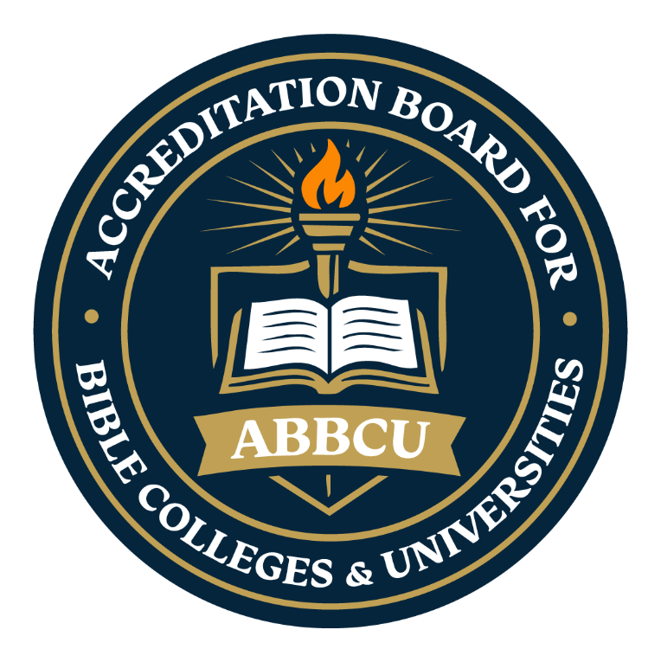
The Accreditation Board for Bible Colleges & Universities
“Maintaining Biblical Integrity in Higher Education”

Doctrinal Standards

Introduction
The Doctrinal Standards establish the foundational theological convictions upheld by the Accreditation Board for Bible Colleges & Universities (ABBCU). These biblical principles serve as the doctrinal framework through which accredited institutions are expected to develop and govern their academic programs, spiritual formation efforts, ministerial training, and institutional mission. By affirming and maintaining alignment with these standards, institutions demonstrate their commitment to the authority of Scripture, theological soundness, and faithful Christian doctrine while fostering unity and consistency across the ABBCU network of Bible colleges, seminaries, and theological institutions.
The ABBCU Doctrinal Standards exist to safeguard the integrity and purpose of biblical higher education by promoting continued adherence to the essential teachings of the Christian faith. These standards provide a foundation for doctrinal accountability, instructional excellence, spiritual growth, and effective ministry preparation. They further encourage institutions to integrate biblical truth into every aspect of institutional life—ensuring that teaching, leadership, governance, and practice reflect a steadfast commitment to Scripture and Christ-centered education.
Purpose of the Doctrinal Standards
The purpose of the Doctrinal Standards established by the Accreditation Board for Bible Colleges & Universities (ABBCU) is to ensure that all accredited institutions affirm, teach, and faithfully uphold the foundational truths of the Christian faith. These standards are intended to preserve theological integrity, encourage the consistent teaching of sound biblical doctrine, and provide a unified framework for spiritual, academic, and institutional accountability throughout the ABBCU network of Bible colleges, seminaries, and theological institutions.
The Doctrinal Standards function as a safeguard for biblical higher education by establishing clear theological expectations for institutions pursuing accreditation through ABBCU. Through adherence to these standards, institutions demonstrate their commitment to the authority of Scripture, doctrinal fidelity, Christ-centered education, and the intentional preparation of students for effective Christian service, ministry, and leadership.
Additionally, these standards promote unity of faith, strengthen institutional credibility, support consistency in biblical instruction, and help ensure that academic programs, ministerial training, and institutional practices remain aligned with historic evangelical Christian doctrine and biblical principles. By maintaining these shared convictions, accredited institutions contribute to a culture of educational excellence that reflects both academic responsibility and spiritual integrity.
Core Doctrinal Standards

1. The Holy Scriptures
The Bible, consisting of the Old and New Testaments, is the inspired, inerrant, and authoritative Word of God. It is the final rule for faith, life, and conduct. Accredited institutions must teach the sufficiency of Scripture and encourage lifelong study of the Word. (2 Timothy 3:16-17; Psalm 119:105)

2. The Nature of God
God is one Being, eternally existent in three persons: Father, Son, and Holy Spirit. He is the Creator and Sustainer of all things, sovereign overall. Institutions must affirm and teach the doctrine of Trinity. (Deuteronomy 6:4; Matthew 28:19)

3. Jesus Christ
Jesus Christ is fully God and fully man. He was born of a virgin, lived a sinless life, died an atoning death, rose bodily from the grave, ascended to heaven, and will return in glory. (John 1:14; Acts 1:11)

4. The Holy Spirit
The Holy Spirit convicts the world of sin, regenerates believers, and empowers the Church for service and mission. He distributes spiritual gifts for the edification of the body. (John 16:8-13; 1 Corinthians 12:4-11)

5. Humanity and Sin
All people are created in the image of God but are fallen and sinful by nature. Redemption is necessary for restored fellowship with God. (Romans 3:23; Genesis 1:26-27)

6. Salvation by Grace Through Faith
Salvation is a gift of God’s grace, received through faith in Jesus Christ alone. It is not earned by works. (Ephesians 2:8-9; John 3:16)

7. Sanctification and Holiness
Believers are called to live holy and set-apart lives, being conformed into the image of Christ through the ongoing work of the Holy Spirit. (Romans 12:1-2; 1 Peter 1:15-16)

8. The Church
The Church is the universal Body of Christ, made up of all born-again believers. It exists to glorify God, edify believers, and evangelize the world. (Ephesians 4:11-13; Acts 2:42-47)

9. The Return of Christ
Jesus Christ will return bodily to judge the living and the dead and to establish His eternal kingdom. This is the believer’s blessed hope. (Titus 2:13; Revelation 22:12)

10. Eternal Destiny
There will be a bodily resurrection of all people—eternal life for the saved and eternal separation for the lost. (John 5:28-29; Revelation 20:11-15)

11. Marriage and Human Dignity
Marriage is a sacred covenant between one man and one woman. All human life is sacred, bearing the image of God and worthy of dignity and respect. (Genesis 2:24; Psalm 139:13-16)
Institutional Doctrinal Compliance Requirement
All applying institutions are required to formally affirm their agreement with and commitment to uphold the Doctrinal Standards established by the Accreditation Board for Bible Colleges & Universities (ABBCU). This Doctrinal Affirmation (Appendix C) must be carefully reviewed and signed by the institution’s senior leadership and/or designated Accreditation Liaison as part of the official accreditation application process.
To maintain ongoing theological integrity and institutional accountability, the signed affirmation must also be renewed during each accreditation review and renewal cycle. Accredited institutions are expected to continuously demonstrate alignment with the biblical convictions and theological principles outlined in the ABBCU Doctrinal Standards through their governance, academic instruction, spiritual formation, institutional practices, and ministerial preparation.
Institutions that fail to maintain adherence to these standards may be subject to review and corrective measures as determined by the ABBCU Accreditation Commission Board. Such actions may include recommendations for improvement, corrective action plans, probationary status, suspension, or other accreditation-related determinations deemed appropriate to preserve the integrity and mission of ABBCU accreditation standards.

The Accreditation Board for Bible Colleges & Universities
“Maintaining Biblical Integrity in Higher Education”

Doctrinal Standards
This form must be signed as an official acknowledgment that the institution has reviewed, accepted, and agrees to uphold, support, and remain in full compliance with the Doctrinal Standards established by the Accreditation Board for Bible Colleges & Universities (ABBCU). Completion and submission of this affirmation confirms the institution’s commitment to maintaining theological integrity and operating in accordance with the biblical principles and expectations required for accreditation.
Doctrinal Standards Affirmation
☐ We, the undersigned representatives of the applying institution, hereby affirm that we have carefully reviewed, understand, and fully agree with the Doctrinal Standards established by the Accreditation Board for Bible Colleges & Universities (ABBCU). We commit to upholding and teaching the biblical, theological, and ethical principles contained within these standards and to preserving the integrity of Christian higher education in alignment with our institution’s mission, values, and spiritual responsibility. Furthermore, we affirm our commitment to maintaining ongoing compliance with these standards throughout the accreditation process and during all periods of accredited status with ABBCU.
Institution Name: ______________________________________________________
Authorized Representative (Print Name): ___________________________________
Title/Position: _______________________________________________
Signature: ____________________________________________ Date: ___________
Accreditation Liaison (Print Name) _________________________________________
Signature: _____________________________________________________________
Date: _________________

Revised 12/24 (DRR) Appendix C

